On page Load

—-------------------

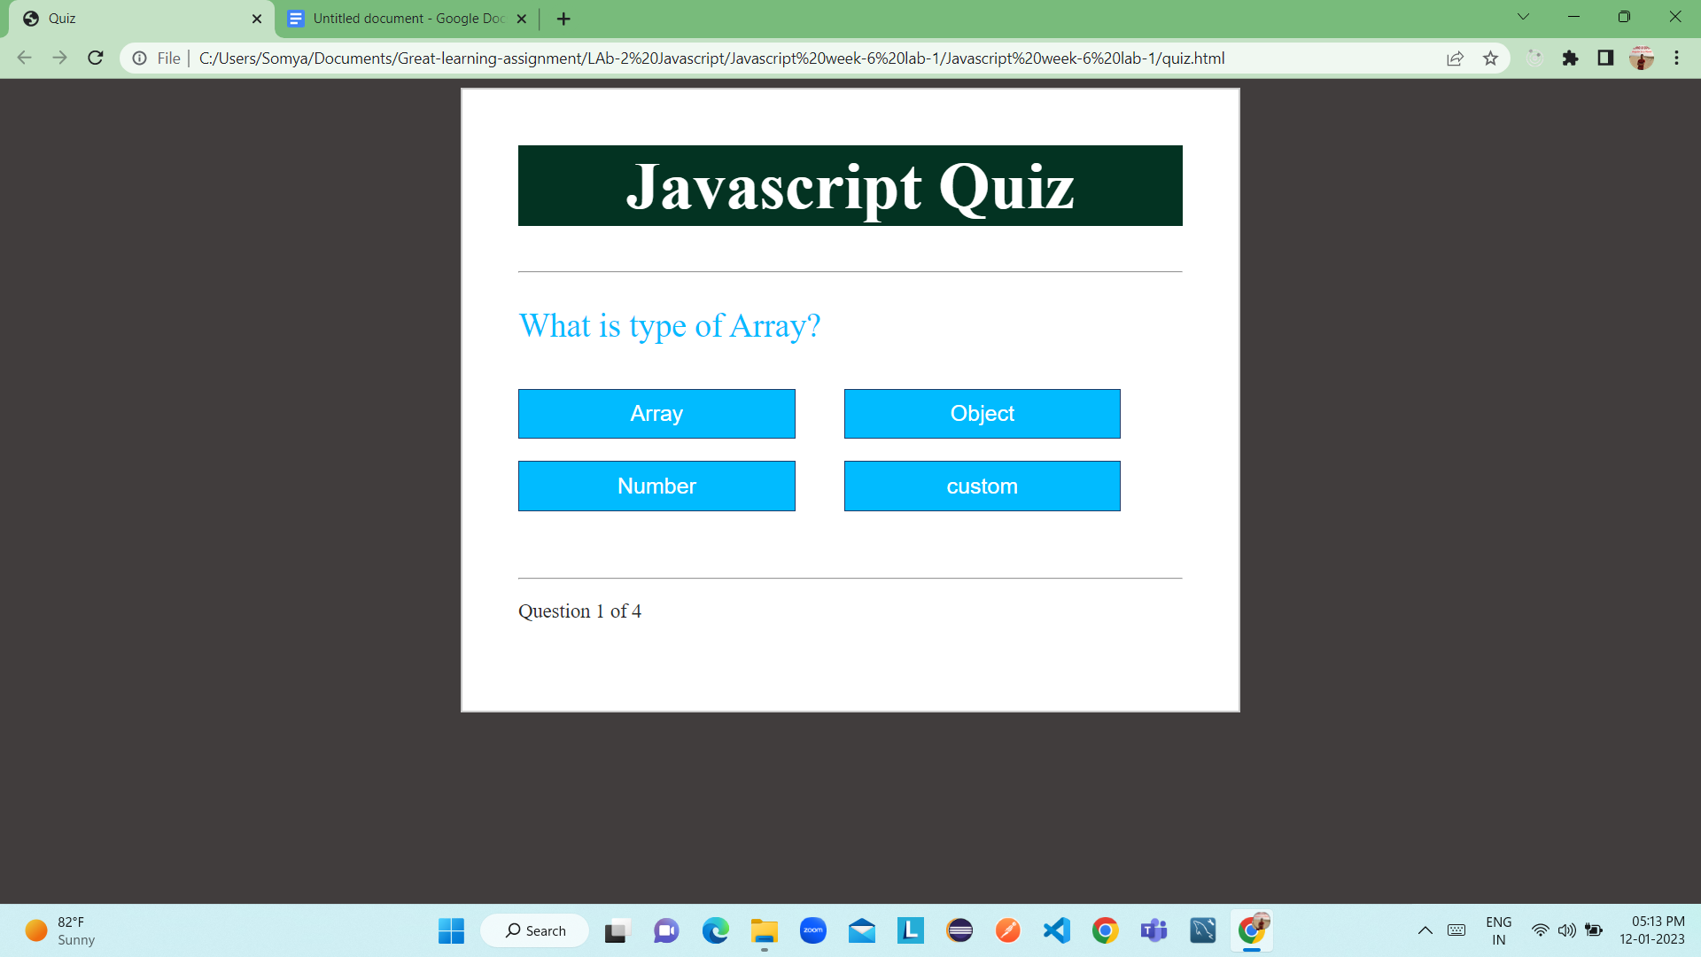

On clicking answer navigated to next Question

—-----------------------------------------------------------

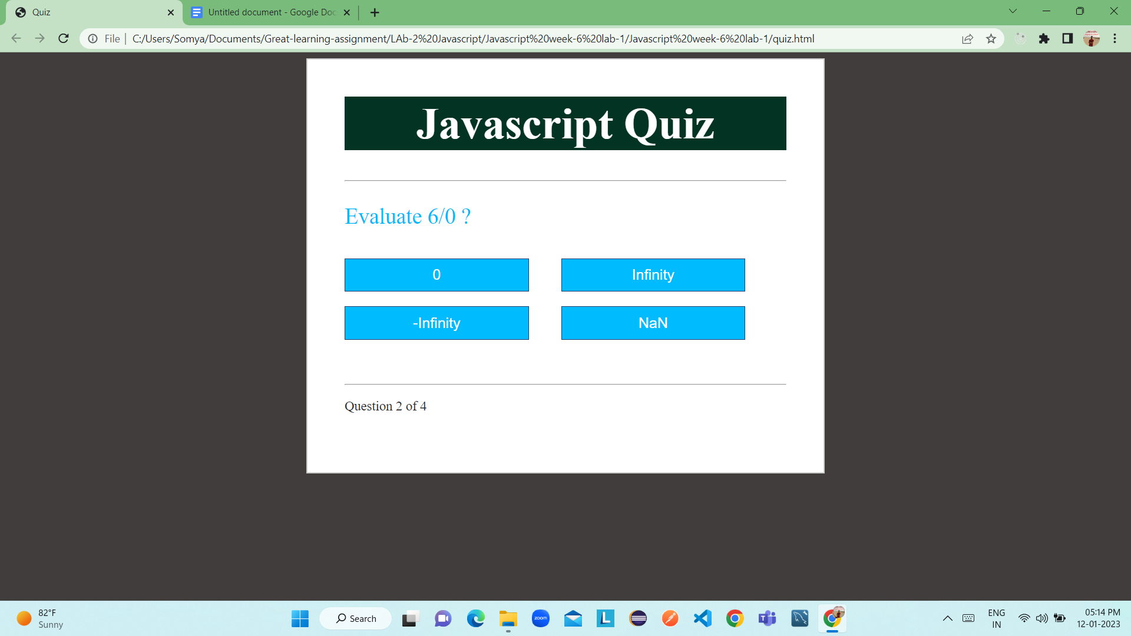

Last Question

—---------------

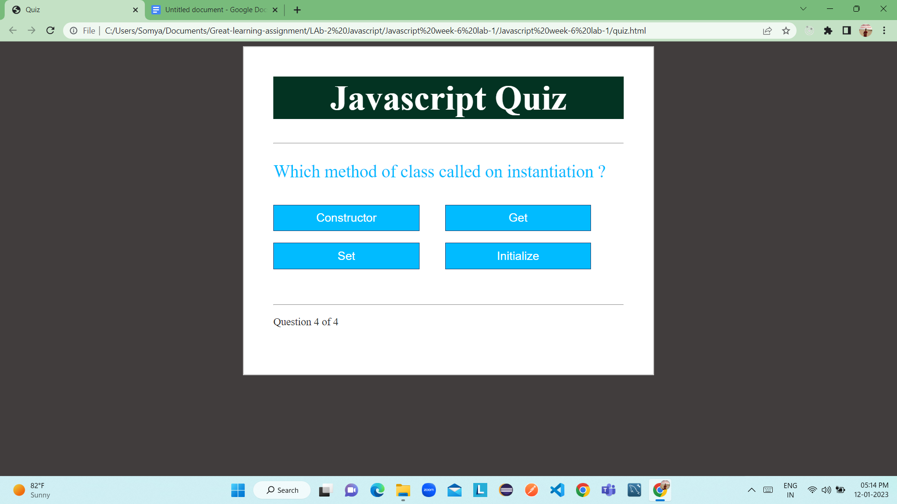

On Answering last Question received mark and percentage

—---------------------------------------------------------------------------

